Presentation + Poster - Instructions

In addition to the final presentation, in which you verbally communicate your design, you will also visually communicate your design using a poster. Your poster should focus on technical details and your value proposition (like you highlighted on your PIE postcard). Both pieces will be used to support your final presentation. See the instructions below for more details on each deliverable.

Presentation

During the Design Showcase, your team will present your design 2 or 3 times to a series of judges who will be rotating around the showcase. Most of the judges will be alumni, local industry leaders on our college advisory board, college faculty, and our TAs. However, our community partners (e.g., therapists, teachers, administrators) will also judge. So, while most judges will have an engineering background, others will not. Keep this in mind as you consider the level of technical detail to include in your presentation. You can assume most are familiar with general engineering and design concepts, but you may need to define or describe technical components in some detail using common language.

Judging rounds will be approximately 12 minutes each, with 5 minutes of presentation time and ~5 minutes of questions, followed by a few minutes for judges to move to the next station.

With your teammates, prepare a 5-minute presentation to summarize your design, its technical merits, and the value proposition for your product. Your presentation should make use of both your poster and your prototype(s) as visual aids. Refer to the poster to highlight testing and technical details, and demonstrate your prototype in action (identifying the features as you demonstrate).
Your presentation should include the…
- Need
  - What opportunity are you addressing?
- Approach
  - How your design works
  - Justified explanations (i.e., via research) of why the key design features were selected
  - How successful your design is based on your constraints & evaluation metrics
  - Next steps to develop a more professional version of your design
- Benefits/Costs
  - How your design will someone’s quality of life
  - Broader impacts if mass produced
  - Risks & trade-offs of your design decisions
  - Avoid made up production costs or sale prices - your prototype bill of material costs have very little relationship to real mass-production costs (i.e., avoid financials as part of this presentation)
- Competition
  - How you’ve differentiated your design from similar products

Remember:
- Your audience already knows about the project background and RFP – do not waste time covering this information!
- They do NOT already know the specific opportunity that you identified for your project
- You are “selling” your design to the review committee – why should the committee consider your design over other proposals?
- Although your presentation will be more technical in nature than the PIE, do not bore your audience with every single design criterion. You can provide a very brief overview of some key problem framing items, but you should focus on how your design helps people and how it works. Q&A might get into more technical details, depending on what interests your judges.
The presentation will be graded by the judges, using the rubric below. The bottom section of the rubric provides judges the opportunity to individually evaluate team members. Individual scores are weighted by individual participation scores.

Topic | Underachieved (score = 0) | Partially Achieved (score = 5) | Fully Achieved (score = 10)
Presentation of Design | Design process & key design features not communicated | Design process & key design features somewhat communicated | Design process & key design features effectively communicated
Quality of Design | RFP is not satisfied | RFP is somewhat satisfied | RFP is well satisfied
Presentation Delivery | Poorly delivered | Adequately delivered | Well-coordinated and engaging
Q&A | Many questions not answered effectively | Some questions answered effectively | All questions answered effectively
Did not Moderately Fully Individual Ratings: participate participated participated
Member 1 _________________________ 1 2 3 4 5
Member 2 _________________________ 1 2 3 4 5
Member 3 _________________________ 1 2 3 4 5
Member 4 _________________________ 1 2 3 4 5
Member 5 _________________________ 1 2 3 4 5
Member 6 _________________________ 1 2 3 4 5

Poster
Your poster supports your presentation by communicating key technical information about your design. Why should a company move forward with YOUR design? What decisions did you make and why were they the right ones? Demonstrate that what you have done is technically sound and well engineered in addition to solving a market need. Your poster should include technical detail and supporting figures. More details of how to structure your poster are included in the poster template. Posters will be printed for you on 11”x17” paper on the morning of the design showcase.

Remember, your poster is the best place to highlight key features that were developed as a result of research, testing, and analysis. You should include design constraints and metrics, as well as your experimental test results (in a succinct table or chart). Your poster should NOT be a copy + paste dump from your report.

Your poster should be submitted as a PDF to the Poster dropbox on Canvas. See the rubric on Canvas.
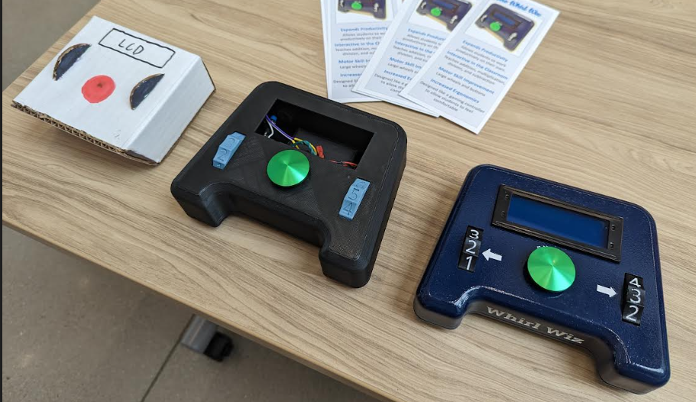
Note: Your presentation should include some brief description of your design development. One effective way to do this is to include visuals of your design iterations on your poster. Another way is to include your prototype iterations such as this…

